1. ***What is data binding in AngularJS?***

Data binding is the automatic synchronization of data between model and view components.

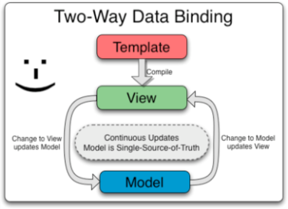ng-bind directive is used in data binding.

**2. *Explain directives in AngularJS.***

Directives are markers on DOM elements such as elements, attributes, css, and more. These can be used to create custom HTML tags that serve as new, custom widgets. AngularJS has built-in directives all the directive have prefix ng. such as ng−bind, ng−model, etc.

**3. *What is scope in AngularJS?***

Scopes are objects that refer to the model. They act as glue between controller and view. It is an object with the available properties and methods. It is available for both the view and the controller.

Syntax: $scope

**4. *What are the advantages of using angularjs?***

|  |  |
| --- | --- |
| provides structure to JavaScript | Modular development |
| Create Templating | Unit Testing Ready |
| Two-way data-binding | Comprehensive |
| Using SPA (Single-Page Applications) | Built by Google |

**Disadvantages**

|  |  |
| --- | --- |
| The framework is complicated | [Bad Performance](http://www.fse.guru/angular-bad-parts-part-2) |
| Confusion, [Complexity](http://www.fse.guru/angular-bad-parts-part-4) | [Name Clashes](http://www.fse.guru/angular-bad-parts-part-3) |
| [Bad Abstractions](http://www.fse.guru/angular-bad-parts-part-1) | [3rd-party modules](http://www.fse.guru/angular-bad-parts-part-5) |

**5. *Explain what Angularjs Routes does.***

Routes is concept of switching views. AngularJS based controller decides which view to render based on the business logic. It allows you to create Single Page Applications. It implements routing the following main steps have to be implemented in your application in any specific order.

**6. *What are the core interface are of hibernate framework?***

The five core interfaces are used in just about every Hibernate application.

1.SessionFactory interface    
2. Session interface  
3.Configuration interface   
4.Transaction interface   
5.Query and Criteria interfaces

**7. *What is REALM?***

A realm is a collection of pages, images and applications that is protected by a login or authentication method. It is a security policy domain defined for a web or application server.

Tomcat has a container security facility that enables the servlet or page author to leave out explicit session tracking in their code.

**8. *Explain the database connection pooling.***

JDBC *connection* pooling is a method used to keep database connections open so they can be reused by others.

Connection pooling is a mechanism to create and maintain a collection of JDBC connection objects

**9. *What is Filter Chaining?***

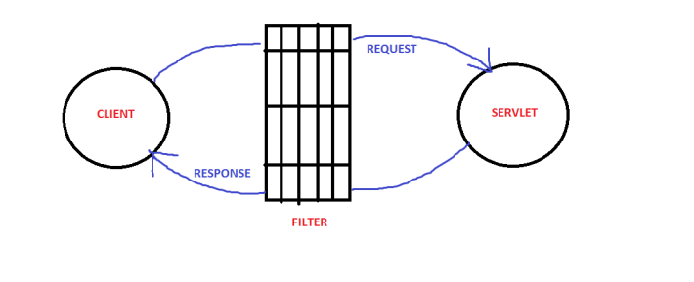The filter implements the javax.servlet.Filter interface, which includes a doFilter() method that takes as input a request and response pair along with a filter chain, which is an instance of a class that implements the javax.servlet.FilterChain interface.

**10. *What is PrimeFaces?***

PrimeFaces is a lightweight JSF component library with one JAR file, which needs no configuration and does not contain any required external dependencies.

==============00=============00============00=================00==============

***What is Hibernate?***

Hibernate is an open source object relational mapping ([ORM](https://searchwindevelopment.techtarget.com/definition/object-relational-mapping)) tool that provides a [framework](https://whatis.techtarget.com/definition/framework) to map [object-oriented](https://searchmicroservices.techtarget.com/definition/object-oriented-programming-OOP) domain models to relational databases for web applications.

***What are the services in AngularJS?***

Services are singleton objects which are instantiated only once in app and are used to do the defined task.

***What are the filters in AngularJS?***

Filters select a subset of items from an array and return a new array. Filters are used to show filtered items from a list of items based on defined criteria.

***What is Model in MVC?***

Model View Controller or MVC as it is popularly called, is a software design pattern for developing web applications. A Model View Controller pattern is made up of the following three parts:

• Model − It is the lowest level of the pattern responsible for maintaining data.

• View − It is responsible for displaying all or a portion of the data to the user.

• Controller − It is a software Code that controls the interactions between the Model and View.

***What is AngularJS?***

AngularJS is a framework to build large scale and high performance web application. It is a framework to build large scale and high performance web application.

***Which are the core directives of AngularJS?***

three core directives of AngularJS.

• ng-app − This directive defines and links an AngularJS application to HTML.

• ng-model − This directive binds the values of AngularJS application data to HTML input controls.

• ng-bind − This directive binds the AngularJS Application data to HTML tags.

***What are AngularJS expressions?***

Expressions are used to bind application data to html. Expressions are written inside double braces like {{ expression}}. Expressions behave in same way as ng-bind directives. AngularJS application expressions are pure JavaScript expressions and outputs the data where they are used.

***What is scope hierarchy in AngularJS?***

Scopes are controllers specific. If we define nested controllers then child controller will inherit the scope of its parent controller.

<script>

var mainApp = angular.module("mainApp", []);

mainApp.controller("shapeController", function($scope) {

$scope.message = "In shape controller";

$scope.type = "Shape";

});

mainApp.controller("circleController", function($scope) {

$scope.message = "In circle controller";

});

</script>

***What are the namespace for PrimeFaces components?***

namespace for PrimeFaces components is as follows:

xmlns:p="http://primefaces.org/ui"

For PrimeFaces Mobile, the namespace is as follows:

xmlns:p="http://primefaces.org/mobile"

***What are PrimeFaces dependencies?***

PrimeFaces only requires a JAVA 5+ runtime and a JSF 2.x implementation as mandatory dependencies. There’re some optional libraries for certain features.

***How to configure PrimeFaces?***

PrimeFaces does not require any mandatory configuration and follows configuration by exception pattern of Java EE. Here is the list of all configuration options defined with a contex-param such as;

<context-param>

<param-name>primefaces.THEME</param-name>

<param-value>bootstrap</param-value>

</context-param>